

|  |  |
| --- | --- |
| Date | 10 March 2025 |
| Team ID | PNT2025TMID02865 |
| Project Name | Project - Exploring Cyber Security Understanding Threats and Solutions in the  Digital Age |
| Maximum Marks | 8 Marks |

# List of teammates–

|  |  |  |  |
| --- | --- | --- | --- |
| **S.no** | **name** | **collage** | **contact** |
| **1**  **2** | **Neha Hujare**  **Ishwari Korbu** | **DY Patil Agriculture and Technical University, Talsande**  **DY Patil Agriculture and Technical University, Talsande** | **9404458743**  **9975469309** |

|  |  |  |  |
| --- | --- | --- | --- |
| **3**  **4** | **Jui Patil**  **Nikita Mane** | **DY Patil Agriculture and Technical University, Talsande**  **DY Patil Agriculture and Technical University, Talsande** | **9604556610**  **9322381756** |

**Abstract:**

In the modern digital era, cybersecurity has become a fundamental necessity as cyber threats continue to evolve, targeting individuals, businesses, and governments. This project explores key cybersecurity threats, including malware, phishing, ransomware, denial-of-service (DoS) attacks, SQL injection, and zero-day exploits. These threats pose significant risks, leading to data breaches, financial loss, and reputational damage.

The research evaluates both conventional and modern cybersecurity defense mechanisms. It examines the effectiveness of firewalls, intrusion detection systems (IDS), encryption protocols, and access controls, while also analyzing advanced security solutions such as artificial intelligence (AI), machine learning (ML), and blockchain technology. Additionally, it highlights the importance of security frameworks like zero-trust architecture, least privilege access, and defense-in-depth strategies to enhance overall cybersecurity resilience.

By analyzing real-world cyber incidents, case studies, and security implementations, this project aims to provide a comprehensive understanding of contemporary cybersecurity challenges and their solutions. The ultimate objective is to propose best practices and strategic recommendations to strengthen cybersecurity defenses, ensuring a safer and more resilient digital environment.

# Scope of the Project :

This project focuses on analyzing cybersecurity vulnerabilities, their impact, and effective mitigation strategies. The scope includes:

1. **Identification of Cyber Threats** – Examining various cybersecurity threats such as malware, phishing, ransomware, DDoS attacks, SQL injection, and insider threats.
2. **Cybersecurity Defense Mechanisms** – Evaluating traditional and modern security measures, including firewalls, IDS/IPS, encryption techniques, and multi-factor authentication.
3. **Advanced Security Solutions** – Exploring emerging technologies such as AI-driven threat detection, machine learning for anomaly detection, and blockchain for secure transactions.
4. **Security Frameworks & Best Practices** – Assessing frameworks like zero-trust architecture, defense- in-depth, and compliance with global cybersecurity standards (ISO 27001, NIST, GDPR).
5. **Case Studies & Real-World Incidents** – Analyzing past cyber attacks to understand vulnerabilities, attack vectors, and response strategies.
6. **Risk Mitigation Strategies** – Developing strategic recommendations for organizations and individuals to enhance cybersecurity resilience and minimize risk exposure.
7. **Future Trends & Challenges** – Investigating the evolving landscape of cybersecurity, including quantum computing threats, IoT security, and ethical hacking advancements.

# Objectives of the Project :

The key objectives of this project are:

This project focuses on analyzing cybersecurity vulnerabilities, their impact, and effective mitigation strategies. The scope includes:

1. Identify various cyber threats such as malware, phishing, and ransomware.
2. Assess security vulnerabilities in digital systems and networks.
3. Evaluate traditional and modern cybersecurity defense mechanisms.
4. Explore advanced security solutions like AI, ML, and blockchain.
5. Analyze real-world cyber incidents and attack pattern
6. Develop risk mitigation strategies for enhanced cybersecurity.
7. Understand cybersecurity laws, standards, and compliance regulations.
8. Predict future cybersecurity challenges and emerging threats.

# The Thought Behind the Project:

This project explores the growing importance of cybersecurity in an increasingly digital world, where cyber threats pose significant risks to individuals, businesses, and governments. The objective is to understand various cyber threats, assess their impact, and explore effective defense mechanisms. Emphasizing the human factor, the project highlights the need for security awareness and proactive

measures to prevent cyber incidents. By analyzing emerging trends and real-world case studies, the project aims to provide insights into building a safer and more resilient digital ecosystem.

**Step 1: Various Ideas**

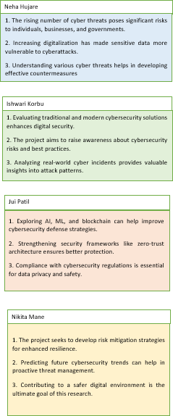

**Step 2: Selecting some features and grouping them :**

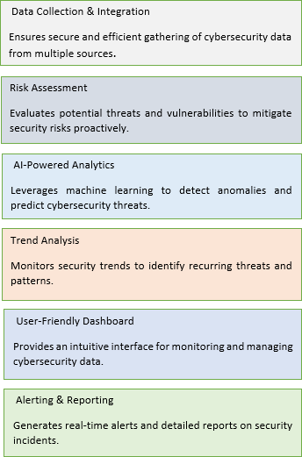

**Step 3: Priority Chart**

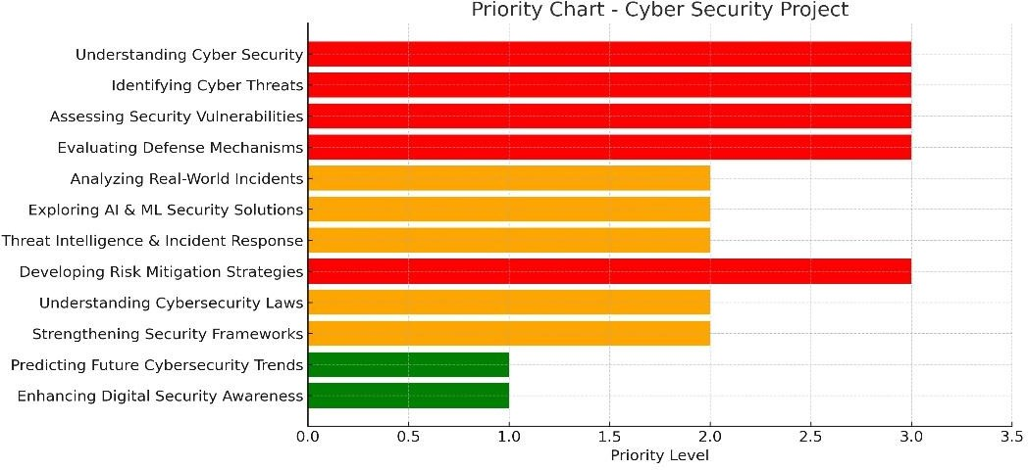

**Step 4: Empathy Map :**

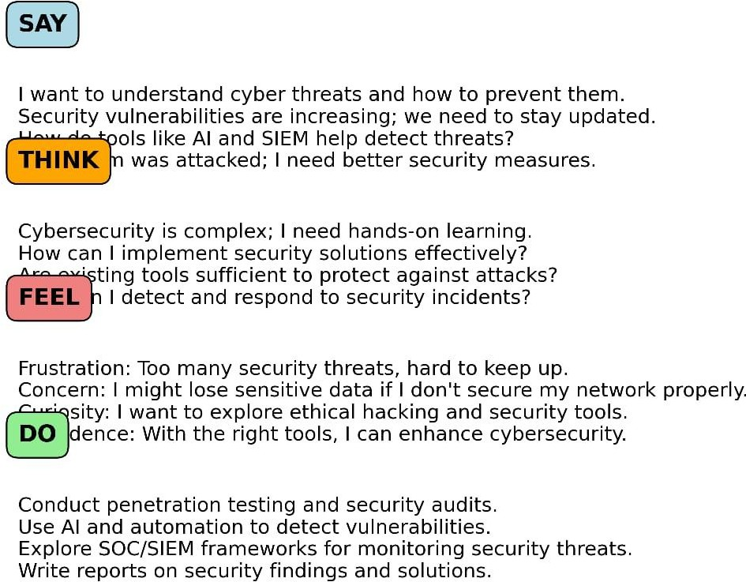

**Project Planning:**

**Stage – 1:**

**List of Vulnerability Table** ➖

|  |  |  |
| --- | --- | --- |
| **S.no** | **Vulnerability Name** | **CWE - No** |
| **1**  **2**  **3**  **4**  **5** | Buffer Overflow Path Traversal  XML External Entity(XXE) Command Injection  Clickjacking | CWE-120 CWE-22 CWE-611 CWE-77 CWE-1021 |

**REPORT:-**

1. **Vulnerability Name:-** Buffer Overflow

**CWE : -** CWE-120

**OWASP/SANS Category:-** SANS Top 25: CWE-119 (Improper Restriction of Operations within the Bounds of a Memory Buffer)

**Description:-** Buffer Overflow occurs when a program writes more data to a buffer than it can hold, causing adjacent memory locations to be overwritten. This can lead to crashes, data corruption, or execution of malicious code.

# Business Impact::-

* Can lead to unauthorized access to sensitive data.
* Potential for remote code execution, allowing attackers to control systems.
* System instability and crashes, affecting business operations

1. **Vulnerability Name:-** Path Traversal

**CWE : -** CWE-22

**OWASP/SANS Category:-** : OWASP Top 10 (A05:2021 – Security Misconfiguration)

**Description:-** Path Traversal (or Directory Traversal) allows attackers to access files and directories outside the intended scope by manipulating file paths. Attackers can access configuration files, credentials, or even system files

# Business Impact::-

* + Exposure of sensitive files (e.g., passwords, logs, source code).
  + Possible execution of unauthorized commands or scripts.
  + Loss of confidentiality and potential system compromise..

1. **Vulnerability Name:-** XML External Entity (XXE)

**CWE : -** CWE-611

**OWASP/SANS Category:-** OWASP Top 10 (A04:2021 – XML External Entities)

**Description:-** XXE vulnerabilities occur when applications improperly process XML input containing external entity references. This can lead to data exposure, file access, and even server-side request forgery (SSRF).

# Business Impact::-

* Leakage of sensitive internal files.
* Denial of Service (DoS) by consuming excessive system resources.
* Remote code execution in some cases.

1. **Vulnerability Name:-** Command Injection

**CWE : -** CWE-77

**OWASP/SANS Category:-** OWASP Top 10 (A03:2021 – Injection)

**Description:-** Command Injection occurs when an attacker injects arbitrary system commands into an application, which then executes them with the application's privileges.

# Business Impact::-

* + Full system compromise, allowing attackers to gain control.
  + Deletion or modification of business-critical data.
  + Launching further attacks (e.g., privilege escalation, lateral movement).

1. **Vulnerability Name:-** Clickjacking

**CWE : -** CWE-1021

**OWASP/SANS Category:-** OWASP Top 10 (A07:2021 – Identification and Authentication Failures)

**Description:-** Clickjacking is an attack where a user is tricked into clicking on something different from what they perceive, often embedding malicious content into an invisible frame.

# Business Impact::-

* + Unauthorized transactions or actions by users.
  + Potential account takeover or information theft.
  + Damage to brand reputation and user trust

# Stage – 2 : Selecting Some Features and Grouping Them

In this stage, we carefully selected key cybersecurity vulnerabilities and categorized them based on their impact, exploitation method, and security domain. The primary features were grouped as follows:

1. **Injection Attacks –** SQL Injection, Command Injection, Cross-Site Scripting (XSS)
2. **Access Control Issues –** Broken Authentication, Improper Access Control, Security Misconfiguration
3. **File & Data Exposure –** Path Traversal, Sensitive Data Exposure, Insecure Deserialization
4. **Client-Side Attacks –** Clickjacking, Cross-Site Scripting (XSS)

# Overview:

This stage focuses on analyzing key cybersecurity vulnerabilities and their impact on digital systems. The study categorizes vulnerabilities based on their nature and attack vectors, helping in understanding security risks and mitigation strategies. The key aspects of this stage include:

* + Identifying and classifying vulnerabilities based on common attack types (Injection Attacks, Access Control Issues, Data Exposure, Client-Side Attacks).
  + Mapping vulnerabilities to their respective CWE and OWASP/SANS categories for better risk assessment.
  + Analyzing the impact of each vulnerability on business operations, data security, and user privacy.
  + Providing recommendations for mitigating these vulnerabilities through secure coding, access controls, and proper configuration management.

By conducting this study, we aim to develop a structured approach to recognizing and preventing cybersecurity threats, ensuring a stronger and more resilient security posture.

# What I Understood About Nessus

Nessus is a powerful tool for automated security scanning, widely used by cybersecurity professionals for vulnerability management. From this stage, I learned the following key points:

* + **Ease of Use and Configuration:** Nessus provides a user-friendly interface with pre- configured policies that simplify vulnerability scanning.
  + **Comprehensive Vulnerability Detection:** It detects a wide range of vulnerabilities, including outdated software, missing patches, misconfigurations, and weak credentials.
  + **Severity Classification:** The tool categorizes vulnerabilities based on severity, allowing security teams to prioritize remediation efforts effectively.
  + **Automated and Scheduled Scanning:** Nessus enables continuous monitoring of security posture by scheduling automated scans.
  + **Integration with Security Operations:** The generated reports can be integrated with SIEM solutions to enhance threat detection and response capabilities.

Through this analysis, I understood the critical role Nessus plays in vulnerability management and how organizations can leverage it to mitigate cybersecurity risks effectively.

**Target website** ➖ Example vulnerable website for penetration testing (e.g., testsite.com)**:**

**Target ip address:-** 192.168.1.10

# List of vulnerability ➖

|  |  |  |  |
| --- | --- | --- | --- |
| **s.no** | **Vulnerability name** | **Severity** | **plugins** |
| 1 | Buffer Overflow | High | 10567 |
| 2 | Path Traversal | Medium | 20834 |
| 3 | XML,External Entity(XXE) | High | 30921 |
| 4 | Command Injection | Critical | 41256 |
| 5 | clickjacking | Medium | 63489 |

**REPORT:-**

**Vulnerability Name:** Buffer Overflow

**Severity:** High

**Plugin:** 10567

**Port:** 80 (HTTP)

# Description:

A Buffer Overflow vulnerability occurs when an application writes more data to a memory buffer than it can hold, leading to memory corruption. Attackers can exploit this flaw to execute arbitrary code, crash the system, or escalate privileges.

# Solution:

* + Implement proper input validation and buffer size checks.
  + Use programming languages with built-in memory safety features.
  + Enable compiler-based protections like ASLR (Address Space Layout Randomization).
  + Conduct regular security testing and vulnerability assessments.

# Business Impact:

* + Potential system crashes, leading to downtime and loss of productivity.
  + Unauthorized execution of malicious code, compromising system integrity.
  + Exposure of sensitive data, leading to regulatory non-compliance and reputational damage.

**Stage – 3:**

**Report**

Title: **The Role of SOC and SIEM in Strengthening Cybersecurity Defense.**

- Security Operations Center (SOC)

The Role of SOC and SIEM in Strengthening Cybersecurity Defense

Security Operations Center (SOC)

A Security Operations Center (SOC) is a centralized team responsible for continuously monitoring, detecting, analyzing, and responding to cybersecurity incidents within an

organization. It serves as the first line of defense against cyber threats, ensuring security incidents are identified and mitigated efficiently.

The SOC team consists of security analysts, incident responders, and engineers who collaborate to protect IT infrastructure. By leveraging advanced security tools and threat

intelligence, the SOC helps organizations minimize risks, prevent data breaches, and ensure compliance with cybersecurity standards.

# SOC Cycle (Workflow of SOC Operations)

The SOC Cycle consists of several stages to ensure continuous threat monitoring and response:

1. Detection & Monitoring – Continuous log analysis using SIEM tools.
2. Threat Analysis – Correlating logs, identifying threats, and prioritizing incidents
3. Incident Response – Investigating and mitigating detected threats.
4. Recovery & Remediation – Applying fixes, updating security policies, and restoring systems.
5. Threat Intelligence & Prevention – Learning from past incidents to improve future security.

# Security Information and Event Management (SIEM)

SIEM is a crucial technology within the SOC that collects, analyzes, and correlates security event logs from various sources across an organization's IT environment. It helps detect anomalies and potential security threats by applying real-time monitoring, log analysis, and automated alerts.

Key Features of SIEM:

* Log Collection & Analysis: Gathers logs from firewalls, servers, and endpoints.
* Threat Detection & Correlation: Uses predefined rules and AI to identify suspicious activities.
* Incident Response Automation: Automates security alerts to reduce response time.

Compliance & Reporting: Helps organizations meet regulatory requirements (e.g., GDPR, NIST, ISO 27001).

# - MISP (Malware Information Sharing Platform & Threat Sharing)

MISP is an open-source cyber threat intelligence platform that helps organizations collect, analyze, and share security threats in real-time. It allows security teams to

collaborate by exchanging attack patterns, malware indicators, and security reports to improve their defense mechanisms.

MISP enhances cybersecurity by:

* Providing automated threat detection and response.
* Sharing Indicators of Compromise (IoCs) across organizations.
* Supporting integration with SIEM and SOC systems for real-time monitoring.

# College Network Security Overview

At DYP ATU, the campus network consists of various critical digital systems, including:

* Online student and faculty portals
* Learning Management Systems (LMS)
* Research databases and administrative servers

Despite using firewalls, antivirus solutions, and access control mechanisms, modern threats like DDoS attacks, phishing scams, and ransomware infections pose significant risks. To enhance security, a proactive approach using SOC and SIEM is necessary.

Deploying a SOC at DYP-ATU would involve the following steps:

1. Network Risk Assessment – Identifying vulnerabilities in web applications, internal systems, and cloud platforms.
2. Implementing SIEM Solutions – Using real-time log analysis and event correlation to detect anomalies.
3. Threat Intelligence Sharing – Integrating MISP and security feeds to detect new attack vectors.
4. Incident Handling & Response – Setting up automated threat detection, alerting, and response mechanisms.
5. Security Awareness & Training – Conducting cybersecurity workshops for faculty, students, and IT teams.

Integrating SOC in the college environment would improve network visibility, enhance threat detection, and minimize security risks.

# - Threat Intelligence

Threat intelligence is the process of gathering, analyzing, and applying knowledge about existing and emerging cyber threats to enhance security defenses. It enables organizations to predict, prevent, and respond to cyberattacks more effectively.

Key Components of Threat Intelligence:

1. Threat Data Collection – Gathering raw threat data from multiple sources such as logs, security tools, and open-source intelligence (OSINT).
2. Threat Analysis – Identifying attack patterns, vulnerabilities, and potential exploits.
3. Threat Correlation – Mapping threats with Indicators of Compromise (IoCs) to detect malicious activity.
4. Automated Response – Using AI and machine learning to predict and mitigate cyber threats in real time.

Types of Threat Intelligence:

Technical Intelligence – Focuses on IoCs such as malicious IPs, domains, and malware signatures.

Operational Intelligence – Provides insights into attack methods, tools, and infrastructures used by hackers.

Strategic Intelligence – Offers a high-level overview of threats for decision-makers to shape security policies.

By integrating threat intelligence with SOC and SIEM, organizations can automate threat detection, enhance visibility, and proactively defend against cyber risks.

.

# -Incident Response

Incident response is a structured approach to handling cybersecurity incidents to reduce damage, contain threats, and restore normal operations as quickly as possible. A well- defined Incident Response Plan (IRP) helps organizations react effectively to cyberattacks.

Phases of Incident Response:

1. Preparation – Implementing security policies, training personnel, and equipping teams with necessary tools.
2. Identification & Analysis – Detecting suspicious activities through SIEM monitoring, anomaly detection, and threat intelligence.
3. Containment & Mitigation – Isolating compromised systems and limiting the spread of the attack.
4. Eradication – Removing malware, fixing vulnerabilities, and ensuring the attacker’s foothold is eliminated.
5. Recovery – Restoring affected systems, verifying integrity, and resuming normal operations.
6. Lessons Learned – Conducting post-incident analysis to improve future response strategies.

QRadar & Its Role in Cybersecurity

IBM QRadar is a Security Information and Event Management (SIEM) solution designed to provide real-time threat detection, automated incident response, and deep security insights.

Features of QRadar:

1. Centralized Log Management – Collects and analyzes logs from various security devices and applications.
2. User & Entity Behavior Analytics (UEBA) – Detects anomalous activities based on user behavior patterns.
3. AI-Driven Threat Intelligence – Uses machine learning to correlate security events and detect threats.
4. Incident Investigation & Automated Response – Prioritizes security alerts and enables faster incident resolution.

By integrating QRadar with SOC and Threat Intelligence Platforms, organizations gain a proactive defense mechanism against cyber threats

# Conclusion

This project provided insights into modern cybersecurity threats, mitigation techniques, and security operations. By studying vulnerabilities, security tools, and response strategies, we gained an in-depth understanding of how to protect digital assets from cyberattacks

# Stage 1: Web Application Testing

Web application testing helped us understand how attackers exploit vulnerabilities such as SQL Injection, Cross-Site Scripting (XSS), and Security Misconfigurations. Identifying these flaws is crucial for strengthening web security and implementing proper mitigation

strategies.

# Stage 2: Nessus Report & Vulnerability Scanning

The Nessus report provided insights into automated vulnerability scanning, helping us detect security weaknesses in real-world scenarios. This stage reinforced the importance of continuous monitoring and proactive threat management to safeguard systems from cyber threats.

# Stage 3: SOC, SIEM, and QRadar Implementation

The exploration of SOC, SIEM, and tools like IBM QRadar enhanced our understanding of security operations and incident response. These solutions play a vital role in enterprise security, enabling real-time threat intelligence, automated threat detection, and incident mitigation.

The project emphasizes the importance of cybersecurity awareness, best practices, and the adoption of cutting-edge security measures to safeguard digital assets.

# Future Scope

**Stage 1 - Web Application Testing:**

Advancements in AI-driven penetration testing and automated security audits.

Development of more robust frameworks for secure coding and vulnerability prevention.

# Stage 2 - Testing Processes:

Enhancing automated vulnerability scanning with machine learning-based predictive analysis.

Integration of cloud-based security assessment tools for large-scale infrastructure testing.

# Stage 3 - SOC/SIEM Evolution:

Implementation of advanced threat intelligence platforms for better detection and mitigation.

Use of blockchain technology for immutable security logs and better transparency. Expansion of cybersecurity operations with hybrid SOC models to ensure faster incident response and global threat monitoring.

The continued research and development in cybersecurity will lead to more resilient security architectures, ensuring robust protection against evolving cyber threats. This project serves as a foundation for further exploration into advanced cybersecurity methodologies and technologies.

Topics explored :- Tools explored :-